What is Private Constructor?
- Private constructor is a special instance constructor which is used in a class that contains static member only.
- If a class has one or more private constructor and no public constructor then other classes are not allowed to create instance of this class; this means you can neither create the object of the class nor can it be inherited by other classes.
- The main purpose of creating private constructor is to restrict the class from being instantiated when it contains every member as static.

Can you create object of class with private constructor in C#?
- No, object of a class having private constructor cannot be instantiated from outside of the class.

What is the use of private constructor in C#?
- It is used to stop object creation of a class.
- It is used to stop a class to be inherited.
- It is used in singleton design patterns, to make sure that the only one instance of a class can ever be created.
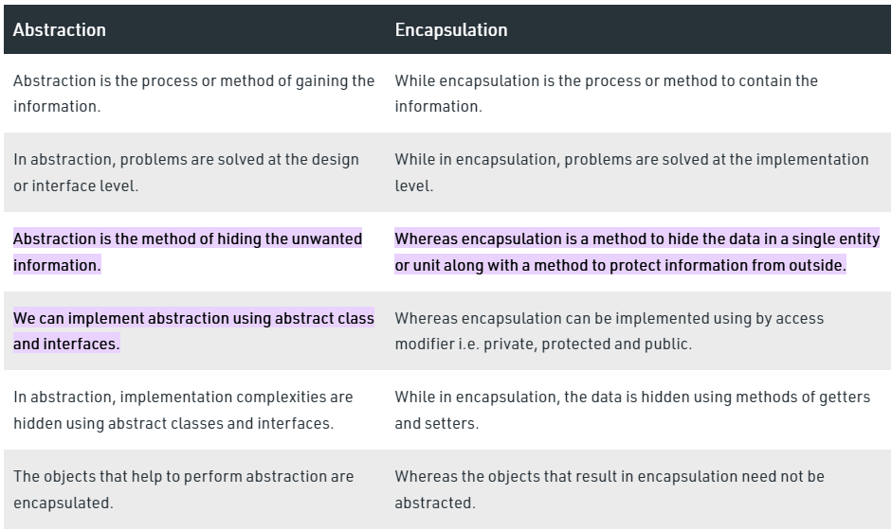

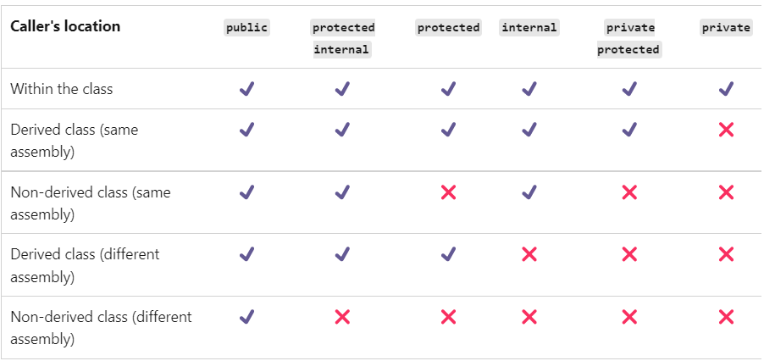

What is the difference between a struct and a class in C#?

Class and struct are both user-defined data types, but have some major differences:

Struct
- The struct is a value type in C# and it inherits from System.Value Type.
- Struct is usually used for smaller amounts of data.
- Struct can’t be inherited from other types.
- A structure can't be abstract.
- No need to create an object with a new keyword.
- Do not have permission to create any default constructor.
Class
- The class is a reference type in C# and it inherits from the System.Object Type.
- Classes are usually used for large amounts of data.
- Classes can be inherited from other classes.
- A class can be an abstract type.
- We can create a default constructor.
Read the following articles to learn more about structs vs classes, Struct and Class Differences in C#.

What is the difference between constant and readonly in C#?

Const is nothing but "constant", a variable of which the value is constant but at compile time. It's mandatory to assign a value to it. By default, a const is static and we cannot change the value of a const variable throughout the entire program.

Readonly is the keyword whose value we can change during runtime or we can assign it at run time but only through the non-static constructor.

What is the difference between the dispose and finalize methods in C#?

In finalize and dispose, both methods are used to free unmanaged resources.

Finalize
- Finalize is used to free unmanaged resources that are not in use, like files, database connections in the application domain and more. These are resources held by an object before that object is destroyed.
- In the Internal process, it is called by Garbage Collector and can’t be called manual by user code or any service.
- Finalize belongs to System.Object class.
- Implement it when you have unmanaged resources in your code, and make sure that these resources are freed when the Garbage collection happens.
Dispose
- Dispose is also used to free unmanaged resources that are not in use like files, database connections in the Application domain at any time.
- Dispose is explicitly called by manual user code.
- If we need to use the dispose method, we must implement that class via IDisposable interface.
- It belongs to IDisposable interface.
- Implement this when you are writing a custom class that will be used by other users.
For more details follow this link, Back To Basics - Dispose Vs Finalize.

What is IEnumerable<> in C#?

IEnumerable is the parent interface for all non-generic collections in System.Collections namespace like ArrayList, HastTable etc. that can be enumerated. For the generic version of this interface as IEnumerable<T> which a parent interface of all generic collections class in System.Collections.Generic namespace like List<> and more.

In System.Collections.Generic.IEnumerable<T> have only a single method which is GetEnumerator() that returns an IEnumerator. IEnumerator provides the power to iterate through the collection by exposing a Current property and Move Next and Reset methods if we don’t have this interface as a parent so we can’t use iteration by foreach loop or can’t use that class object in our LINQ query.

What is the difference between late binding and early binding in C#?

Early Binding and Late Binding concepts belong to polymorphism in C#. Polymorphism is the feature of object-oriented programming that allows a language to use the same name in different forms. For example, a method named Add can add integers, doubles, and decimals.

Polymorphism we have 2 different types to achieve that:
- Compile Time also known as Early Binding or Overloading.
- Run Time is also known as Late Binding or Overriding.

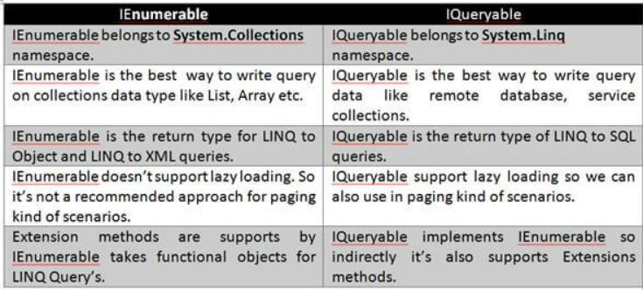

What’s the difference between the Array.CopyTo() and Array.Clone()?

The Array.Clone() method creates a shallow copy of an array. A shallow copy of an Array copies only the elements of the Array, whether they are reference types or value types, but it does not copy the objects that the references refer to. The references in the new Array point to the same objects that the references in the original Array point to.

The CopyTo() static method of the Array class copies a section of an array to another array. The CopyTo method copies all the elements of an array to another one-dimension array. The code listed in Listing 9 copies contents of an integer array to an array of object types.

What is a Hashtable in C#?

A Hashtable is a collection that stores (Keys, Values) pairs. Here, the Keys are used to find the storage location and is immutable and cannot have duplicate entries in a Hashtable. The .Net Framework has provided a Hash Table class that contains all the functionality required to implement a hash table without any additional development. The hash table is a general-purpose dictionary collection. Each item within the collection is a DictionaryEntry object with two properties: a key object and a value object. These are known as Key/Value. When items are added to a hash table, a hash code is generated automatically. This code is hidden from the developer. Access to the table's values is achieved using the key object for identification. As the items in the collection are sorted according to the hidden hash code, the items should be considered to be randomly ordered.

The Hashtable Collection

The Base Class libraries offer a Hashtable Class that is defined in the System.Collections namespace, so you don't have to code your own hash tables. It processes each key of the hash that you add every time and then uses the hash code to look up the element very quickly. The capacity of a hash table is the number of elements the hash table can hold. As elements are added to a hash table, the capacity is automatically increased as required through reallocation. It is an older .Net Framework type.

Declaring a Hashtable

The Hashtable class is generally found in the namespace called System.Collections. So to execute any of the examples, we have to add using System.Collections; to the source code. The declaration for the Hashtable is:
- Hashtable HT = new Hashtable ();

